AI Marketing Agent — Architecture
Sep 30, 2026 · @akshat

1. At a glance
Scheduled GitHub Actions workflows trigger three small job services (lead, outreach, content) that read and write one Supabase database, call an LLM on our own machine, and ask people for approval in Slack before anything leaves the company. It finds companies that need AOSP and embedded engineering, emails them, handles replies, and publishes a weekly technical post. The research behind these choices is in the companion document, AI Marketing Agent — Research and Technical Proposal.
Design principles
- State lives in one place. Supabase holds every lead, email, reply and post. Jobs are stateless and can be re-run.
- Tables are queues. Each job claims rows in the status it owns, so late, dropped or duplicate runs cannot double-send or lose work.
- Humans approve what leaves the company. Leads, emails and posts each pass a Slack approval gate; the model drafts, people decide.
- Models stay on our hardware. The LLM endpoint is private; lead data never goes to a third-party model provider.
- Slack is the control surface, the dashboard is the window. Approvals and errors appear in Slack; the dashboard shows leads and starts runs.
- The host is not always on. The job services and the LLM run on one machine that is powered on only for two scheduled windows (about 60 of 168 hours a week). Work that arrives while it is off waits in the database and is picked up by the next window.
Scope
In scope | Out of scope
Lead discovery from public sources and approved LinkedIn alert emails | Scraping LinkedIn or job aggregators
Email sequences, reply classification, drafted responses | Fully autonomous replies with pricing or scope commitments
Weekly blog drafting, review and publishing | Paid ads management (audiences are a later, legal-reviewed step)
Slack approvals, alerts, and a read-mostly dashboard | A full-featured CRM UI

2. System context
The system has four zones with one authenticated door each; only the workflows reach into all of them, and people meet the system in Slack and the dashboard.
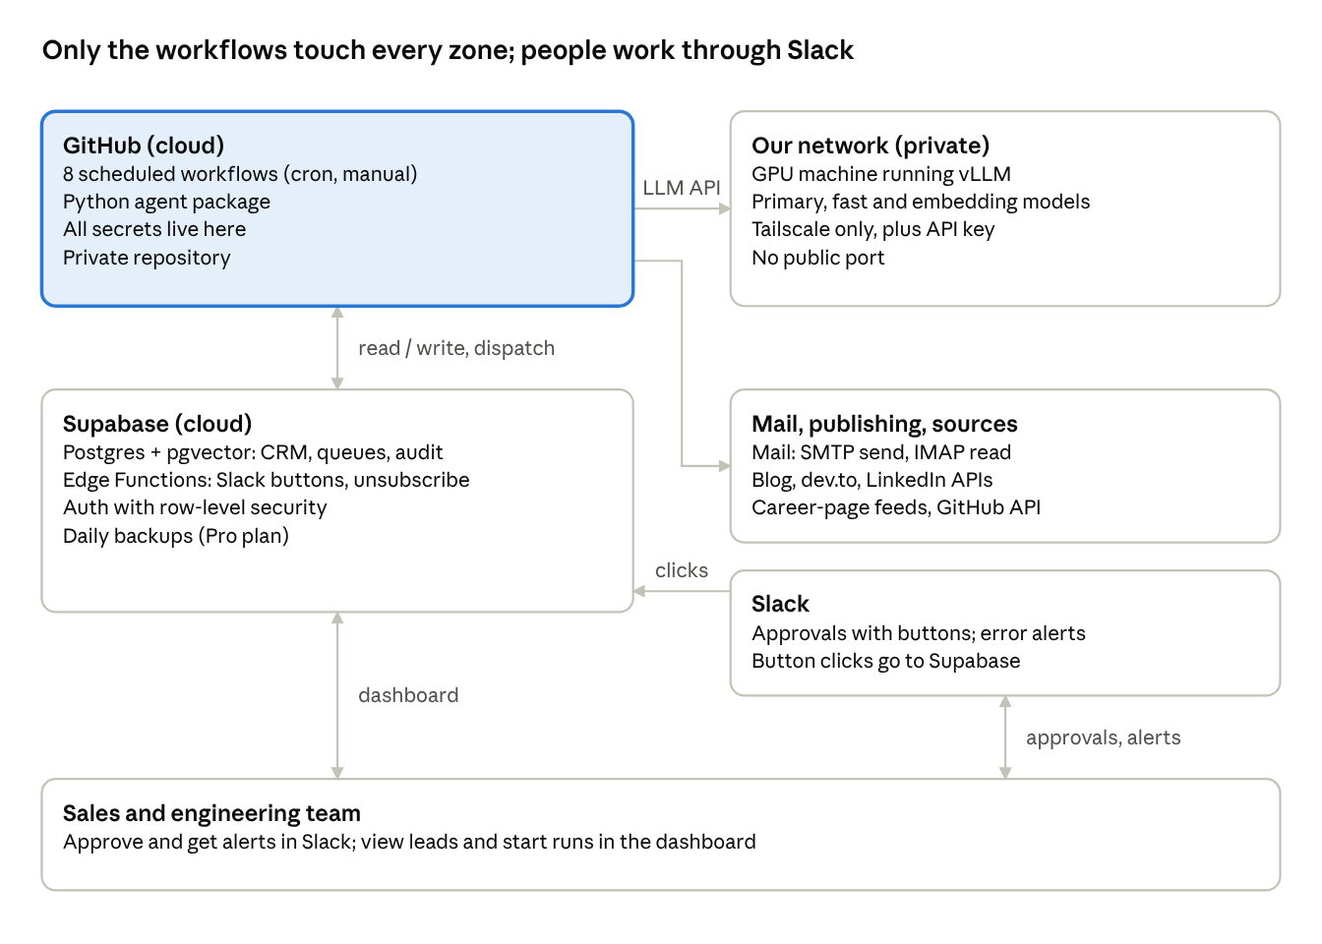
system context · 5 zones, 6 links
Arrows show who calls whom. Workflows call the job services on our host; the services call the model, the database and the outside services. Supabase calls the GitHub API to start a workflow after an approval or a Start run click. Slack calls Supabase when a button is clicked. Nothing in Supabase or Slack can reach the GPU machine directly.
Diagram note: the box labelled agent code runs as the three job services on the host, not inside the workflow runners. The host and the LLM are reachable only during the windows in section 3.

3. Components
Ten components, each with one job and a narrow interface. Any of them can be swapped without touching the others as long as the interface holds.
Component | Responsibility | Technology | Interface
Scheduler and runners | Run each workflow on its trigger, join the tailnet and call the job services; hold only the secrets workflows need | GitHub Actions (private repo), hosted runners | Cron, workflow_dispatch, repository_dispatch
Job services | Collectors, parsers, prompts, pipeline steps, senders | Python 3.12: shared agentkit library plus three FastAPI services (lead, outreach, content) on the host | HTTP job contract: GET /health, POST /jobs/{name}, GET /runs/{id}, header X-Job-Token
LLM server | Serve primary, fast and embedding models while the host is up | vLLM on our GPU machine, started at boot as a systemd service | OpenAI-compatible HTTP, API key, private network only
Private network | Let runners reach the LLM machine without a public port | Tailscale ephemeral node per job | Private IP and port
Database | Leads, contacts, emails, replies, posts, decisions, runs, embeddings | Supabase Postgres with pgvector | SQL from the agent (service key), REST/JS from the dashboard (anon key + RLS)
Edge Functions | Slack button handler, unsubscribe endpoint, dashboard-to-Actions trigger | Supabase Edge Functions (Deno) | HTTPS with signature or JWT verification
Slack app | Approval messages, buttons, alerts | Slack app with incoming webhook, bot token and interactivity URL | Block Kit messages; signed interaction payloads
Dashboard | Show leads, status, runs, metrics; start pipeline runs | Next.js with Supabase Auth | Reads via RLS; Start run calls an Edge Function
Mail service | Send outreach; receive replies and LinkedIn alert emails | SMTP and IMAP on two or three mailboxes (or SES for sending) | SMTP 587, IMAP 993
Publishing targets | Own blog (canonical), dev.to, LinkedIn company page | CMS API, Forem API, LinkedIn Posts API | HTTPS with API key or OAuth token
The agent code is three small services that share one library (agentkit), so each job can be run, tested and restarted on its own. What gets deployed is the workflows, the Edge Functions, the LLM server, and a docker compose stack on the host.

Host availability and windows
The GPU machine and the three job services do not run around the clock. They run in two scheduled windows (IST, matching scheduler/jobs.yaml); everything else waits in Supabase.
- Night window, daily 01:30–04:30. Health check (01:47), then lead-service: collect_sources (02:07), ingest_alerts (02:37), qualify (03:07), enrich_contacts (03:37). Also the early US send run (see section 5). Mostly the fast model.
- Day window, Monday to Friday 09:00–17:00. outreach draft (09:13) and send (11:13), poll_replies hourly (09:13–16:13), reply drafting and sending, and the content jobs (plan_topics Monday 09:17, draft_post Tuesday 09:17, publish Thursday 10:17, collect_metrics Friday 16:17). Primary model.
- Power on. A BIOS/RTC wake alarm or a scheduled smart plug starts the machine 30 minutes before the window; Tailscale, vLLM, the embedding server and the compose stack start at boot (systemd, restart policies). Allow 10–15 minutes for boot and model load. Wake-on-LAN from an always-on device is the on-demand alternative (decision 9).
- Power off. An idle-shutdown timer after the window ends powers the machine down only when every service reports no running job (the running list in GET /health is empty) and the LLM has no active request. A job that overruns keeps the host up.
- Runner behaviour. The first step of every workflow waits up to 15 minutes for the service /health and the LLM /v1/models. If they still do not answer, the workflow writes a skipped row in agent_runs and ends without failing. Slack is alerted only when a window that should have been up is missed twice in a row.
- Work outside a window. A Slack approval is recorded at once and the follow-up dispatch fails harmlessly if the host is off. Every dispatch-triggered job (enrich_contacts, send, send_reply, publish) is also part of a scheduled sweep in the next window, which acts on approved rows. Approvals expire after 72 hours, so a weekend does not lose them. A Start run or Retry click outside a window is recorded as skipped and the Slack message names the next window.
- Effect on reply speed. The one-hour acknowledgement holds inside the Day window; replies that arrive overnight or at the weekend are acknowledged within about an hour of the next Day window opening.

4. Lead lifecycle
A lead passes two human gates in Slack before any email is sent: one to accept the company, one to send the drafted email. Dashed boxes are exits; the lead stays in the database with that status.
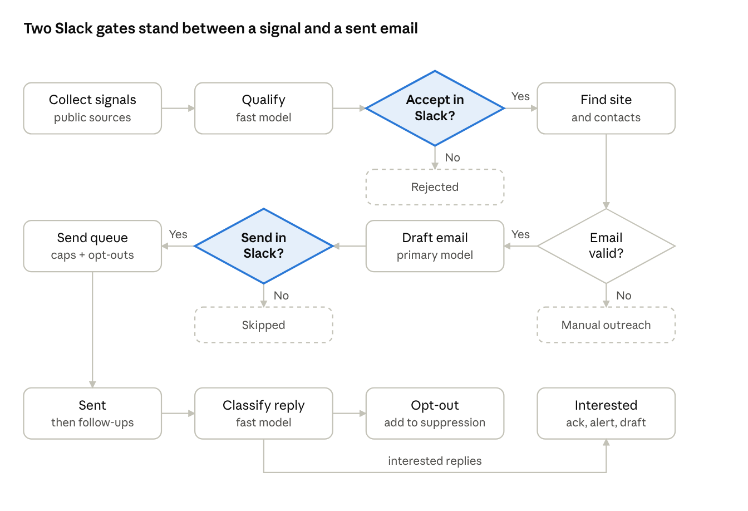
lead lifecycle · 2 approval gates, 3 exits
Replies add a third gate: interested replies get an automatic acknowledgement within the hour, but the substantive answer is drafted for a person to review and send in Slack. "Manual outreach" means no verified address was found, so Slack shows the contact-form URL instead of a Send button. Follow-ups repeat the send path with the same suppression and cap checks, and a reply from the company stops the sequence.

5. Workflows and schedule
Eight workflows do all the work; each reads rows in one status and moves them to the next. Each is a GitHub workflow that triggers jobs on a service (mapping below). Times are IST, follow scheduler/jobs.yaml, fall inside the two host windows and are examples; the exact minute is off the hour to avoid GitHub's top-of-hour delays.
Workflow | Trigger | LLM | Reads | Writes / effect
lead-discovery | Daily 02:07 in the night window; also Start run | Fast | Public sources, ATS feeds, GitHub API | lead_signals, companies (status qualified candidates)
alerts-to-slack | Daily 02:37 in the night window; also Start run | Fast | Job-alert mailbox (IMAP) | Posts candidates to Slack; writes approvals (pending)
contact-enrich | After an Accept (dispatch) | Fast | Accepted company website | contacts with verification status
outreach-draft | After enrichment; also daily sweep | Primary | Verified contacts, signal, service catalogue | emails (drafted); posts draft to Slack
outreach-send | Weekdays 11:13 (India, Middle East, APAC contacts) and Tue–Sat 01:57 (US contacts); also on email approval when the host is up | None | emails (approved) | SMTP send; emails (sent); enforces caps and suppression
replies | Hourly 09:13–16:13 on weekdays (Day window) | Fast; primary for drafts | Reply mailbox (IMAP) | replies, acknowledgements, Slack alerts, draft responses
content | Weekly in the Day window; publish Thursday and on approval | Primary | Topic backlog, RAG store | CMS draft; on approval publishes to blog, dev.to, LinkedIn
health | Daily 01:47 at the start of the night window; waits for the host to boot | None | LLM endpoint, Supabase, mailboxes | Slack alert on any failure
Mapping to the code. lead-discovery is lead-service collect_sources and qualify; alerts-to-slack is ingest_alerts; contact-enrich is enrich_contacts; outreach-draft, outreach-send and replies are the outreach-service jobs draft, send, poll_replies, draft_replies and send_reply; content is plan_topics, draft_post, publish and collect_metrics on content-service. The workflow files are lead.yml, outreach.yml, content.yml, dispatch.yml (Slack-triggered) and health.yml.
Dispatch events. lead-accepted runs enrich_contacts; email-approved runs send; reply-approved runs send_reply (approving a reply draft sends it; drafting is part of poll_replies); post-approved runs publish; run-job starts an allow-listed job from the dashboard or a Slack Retry.
US contacts. Sends follow the rule of 09:00–17:00 in the recipient's time zone. The Day window covers India, the Middle East and APAC; US contacts are reachable only in the night window (US afternoon), so US sending is limited to the 01:57 run.

Conventions every workflow follows
- Claim, process, commit. Select rows with FOR UPDATE SKIP LOCKED, do the work, write the result and next status in one transaction per row.
- Concurrency group per workflow name so two runs never overlap; each service also allows one run per job at a time and answers 409.
- Health first. Wait up to 15 minutes for the service and the LLM to answer, because the host may still be booting. If they do not, record a skipped run in agent_runs and exit; the next window resumes from the queue.
- Idempotency keys on anything that leaves the system (emails, publishes), unique in the database.
- Run record. Each run writes one agent_runs row with counts and status; failures also go to Slack.
- Secrets only from GitHub Secrets (workflows) or the host's .env (services); logs carry row IDs and counts, never personal data or message text.

6. Slack approval design
Every approval is a row in approvals plus a Slack message; a button click updates the row and triggers the next step, exactly once. Slack is the interface, but the database is the record.

Message types
Type | Channel | Buttons | On approve | On reject
Lead candidate | #aosp-leads | Accept, Ignore | Company saved as qualified; contact-enrich dispatched | Company marked rejected, not shown again
Email draft | #outreach-approvals | Send, Edit, Skip | Email marked approved and queued for outreach-send | Email marked skipped; sequence stops
Reply draft | #replies | Send, Edit, Skip | send_reply job sends it from the right mailbox, threaded | Left for a person to write
Blog draft | #content | Approve, Request changes | Post scheduled for publish | Back to drafted with reviewer note
Failure or health alert | #agent-alerts | Open run, Retry | Re-dispatches the workflow | None
Edit opens a Slack modal with the text; Save writes the edited text to the row and re-posts the message for a final Send. The interaction function handles the modal open and submit events as well as button clicks, and the Retry and Open run buttons on alerts call trigger-run.

Button handling
- Slack sends the click as a signed POST to the interactivity URL, an Edge Function.
- The function verifies Slack's signature and timestamp (rejects anything older than five minutes) before reading the payload.
- It checks the Slack user against the team_members allow-list and the role needed for that message type.
- It checks that the approval's kind matches the button, then in one transaction updates the approvals row only if it is still pending and unexpired; a mismatched or repeated click changes nothing.
- It records the decider's Slack ID, the time and the action, then replaces the buttons with the outcome ("Accepted by <name>").
- It dispatches the next workflow through the GitHub API using a token limited to workflow dispatch on this repository. If the dispatch fails or the host is off, the decision stays recorded and the next window's sweep acts on it.
- It answers Slack within three seconds; longer work happens in the dispatched workflow.

Rules
- Buttons carry only an approval ID, never lead data or secrets.
- Approvals expire after a set time (default 72 hours) and are marked expired, so a stale queue never sends old emails.
- If Slack is down, nothing is sent; approvals wait in the database and are re-posted when Slack returns.
- Approvals decided while the host is off are acted on by the next window; the message shows "Approved, will run at the next window".
- Channels are private and limited to the sales and engineering group, because messages contain contact details.

7. Data architecture
The schema has five groups; every table that drives work carries a status column and a timestamp, and nothing is deleted without a record. Column-level detail belongs in the migration files; this section fixes the shape.
Group | Tables | Purpose
Leads | companies, contacts, lead_signals | Who we might work with, how to reach them, and why
Outreach | campaigns, emails, replies | What we sent, what came back
Content | content_posts, topics | Blog pipeline and idea backlog
Control | approvals, team_members, suppression_list, agent_runs, send_counters | Decisions, who may decide, who never to contact, job history
Knowledge | examples, knowledge_docs, knowledge_chunks, prompt_versions, retrieval_logs (vector columns also on topics and content_posts) | Vectors for de-duplication and retrieval over our own material

Status machines
Entity | Statuses (in order) | Terminal states
Company | candidate → qualified → contact_found → verified → engaged | rejected, suppressed, closed
Email | drafted → approved → sending → sent | skipped, bounced, expired
Reply | received → classified → acknowledged → handled | unsubscribed
Post | idea → drafted → in_review → approved → published | rejected, publish_failed
Approval | pending → approved or rejected | expired

Queue and integrity rules
- Claiming: SELECT … FOR UPDATE SKIP LOCKED inside a transaction, limited by a batch size.
- Uniqueness: companies.domain, emails(contact_id, campaign_id, step) and every idempotency_key are unique constraints, so duplicates fail in the database, not in code.
- Suppression: a database function is_suppressed(email) is called by the sender in the same transaction that marks an email sending.
- Caps: daily send counters are rows updated with a conditional increment, so two runners cannot exceed the cap together. The same row also holds bounced and complaint counts and a paused flag per mailbox, which drive the automatic pause, and a global daily cap sits on top of the per-mailbox cap. These columns are a small migration still to be written.
- Audit: approvals and agent_runs are append-only; corrections are new rows.
- Retention: contacts with no engagement after 12 months are deleted; suppression entries are kept as hashed addresses so opt-outs survive deletion.

Access model
Role | Key | Can do
Agent jobs | service_role, held only in the host's .env | Full access through the pooled connection string
Dashboard users | Supabase Auth JWT + Row Level Security | Read leads and runs; call the Start run function
Edge Functions | Own service key in function secrets | Update approvals, write suppression_list

8. LLM serving and routing
All agent code calls one internal function, llm.complete(task, input), which picks the model by task name and talks to our endpoint through the OpenAI-compatible API. Changing a model is a configuration change, not a code change.

Endpoint contract
Item | Design
Base URL and key | LLM_BASE_URL, LLM_API_KEY from GitHub Secrets; the URL is a Tailscale address
Routes used | /v1/chat/completions, /v1/embeddings, /v1/models (health)
Structured output | JSON schema (Pydantic model) passed with every classification or extraction call; the response is validated and retried once on failure
Timeouts | 120 s for drafts, 30 s for classification; 2 retries with back-off
Concurrency | Client semaphore of 2–4 requests; matches the GPU's batch capacity
Reasoning effort | Set explicitly per task (low for classification), because Qwen3.8 defaults to the highest setting

Routing table
Task name | Model | Output | Validation
lead.qualify | Fast | JSON: relevant, service fit, confidence, reason | Schema; confidence threshold
lead.extract_company | Fast | JSON: name, domain, country, industry | Schema; domain must resolve
outreach.classify_reply | Fast | One label from a fixed set | Label must be in set
outreach.draft | Primary | Subject and body text | Length, required footer, no unknown company names, banned-phrase list
outreach.draft_reply | Primary + retrieval | Reply text and cited source snippets | Human approval always
content.draft_post | Primary + retrieval | Markdown with code blocks | Human approval always; duplicate check by embedding
embed | Embedding model | Vector | Dimension check
Task names are the ones in config/routing.yaml (lead.extract_company is still to be added there). Until the evaluation set has chosen models, most tasks run on the dev alias (Qwen3.5-9B); the primary and fast repository IDs are confirmed on Hugging Face before the first download.

Prompts and evaluation
Prompts are versioned in the prompt_versions table (one active row per task) with a file in the service's prompts directory as fallback, plus few-shot examples written by our team. A fixed evaluation set (100 job posts, 60 contact pages, 80 replies, and 20 each of email, reply and blog drafts, built up from a first 40-item set; see the LLM Playbook) runs in CI on every prompt or model change and reports accuracy against labelled answers. A change that lowers accuracy does not merge.

Capacity and guardrails
- Two models resident if memory allows (primary plus fast); otherwise the daily window is split into a fast-model pass then a primary-model pass.
- Token and latency figures per run are stored in agent_runs to size hardware.
- Escalation. A failed check gets one retry with the error appended; a second failure goes once to the next model tier, then to Slack as needs human. Every attempt is logged with ids and outcomes only.
- Model load. Models load at boot. The health step waits for /v1/models before any job starts, so a slow load costs time, not failed runs.
- The model never receives secrets, and never sends email or posts on its own: its output is text stored in a row, and a separate code path performs the action after approval.

9. Security architecture
Four trust zones, each reached only through one authenticated door: GitHub holds secrets, our network holds the model, Supabase holds the data, and Slack and the mail service are external. Lead data is personal data, so the design assumes any single credential can leak and limits what it opens.

Secrets and who holds them
Secret | Held in | Used by | If leaked
Supabase service_role key / DB URL | Host .env (services); Edge Function secrets | Job services; Edge Functions | Full data access: rotate immediately; restrict DB by network allow-list where possible
LLM API key + Tailscale auth key | Host .env for the LLM key; GitHub Secrets for the Tailscale OAuth client | Agent jobs | Key alone cannot reach the model without the tailnet; auth keys are ephemeral and single-use
SMTP / IMAP credentials | Host .env | Send and reply jobs | Mail abuse: use app passwords, rotate, per-mailbox caps limit damage
Slack bot token and signing secret | Edge Function secrets; host .env for posting | Slack posting and verification | Fake approvals if signing secret leaks: rotate
dev.to key, LinkedIn OAuth tokens | Host .env | content | Unwanted posts: revoke token
GitHub dispatch token | Edge Function secrets | Dashboard Start run and Slack Retry | Can only trigger workflows in one repository
Where secrets live. Service-side secrets (database URL and service key, SMTP and IMAP credentials, publishing tokens, LLM key, Slack bot token) sit in the host's .env, readable only by the service user, on an encrypted disk because the machine is powered off between windows. GitHub Secrets hold only what workflows need: JOB_TOKEN, the Tailscale OAuth client, the service and LLM URLs, the LLM key for the health check and the Slack alert webhook. The job services accept only requests that carry X-Job-Token and are reachable only over the tailnet.

Controls
- Network: the model port listens only on the Tailscale interface; Tailscale ACLs let the CI tag reach that one port and nothing else on our network.
- Database: Row Level Security on every table; the dashboard uses only the anon key and the user's JWT; the service key never reaches a browser.
- Identity: dashboard and Slack actions map to team_members with roles (viewer, approver, admin). Only approvers can accept leads or send emails.
- Repository: private; branch protection on main; workflows run only from main for schedules; no pull_request_target workflows with secrets; third-party actions pinned to commit hashes.
- Input safety: scraped pages, alert emails and replies are untrusted text. They are passed to the model only as data in a delimited block, the model has no tools, and its output is validated and approved before any action. This limits prompt-injection damage to a bad draft that a person will see.
- Logs: no email addresses, bodies or prompts in Actions logs; Supabase logs are restricted to admins.
- Data protection: business contacts only; source URL and date stored for each; country filter; deletion on request; retention limit of 12 months without engagement.

Threats considered
Threat | Countermeasure
Attacker forges a Slack click | Signature and timestamp verification; user allow-list; one-time approval rows
Malicious web page or reply tries to steer the model | Model has no tools; output schema-checked; human approval before sending
Runner or log leaks secrets | Secrets masked; minimal scopes; rotation runbook
Model endpoint exposed to the internet | No public port; API key; tailnet ACL
Duplicate or runaway sending | Idempotency keys, database caps, auto-pause on bounce or complaint thresholds

10. Failure handling and observability
Every failure ends in one of three outcomes: retried automatically, skipped safely and picked up next run, or raised in Slack for a person. Nothing fails silently, and nothing is sent twice.
Failure | Detection | Automatic response | Person involved?
LLM machine offline | health check; /v1/models still fails after the 15-minute boot grace | Job records skipped run; queue waits for next run | Slack alert if it is down inside a scheduled window on two consecutive checks; being off outside windows is normal
Tailscale join fails | Step error | Retry once; then skip | Alert
GitHub run delayed or dropped | health compares last successful run time per workflow | Next run catches up from the queue | Alert if a workflow is overdue
Supabase unreachable | Connection error | Retry with back-off; job exits without side effects | Alert
Model returns invalid JSON | Schema validation | One retry; then row marked needs_review | Shown in Slack if it recurs
Site blocks or times out | HTTP status | Skip with back-off; domain cooldown | Weekly summary of blocked sources
Email bounce (hard) | Bounce message or SMTP code | Contact marked invalid; sequence stops | None
Bounce rate over 3% or any spam-complaint signal | Rolling counters | All sending paused | Alert; person resumes
SMTP send error mid-batch | Exception | Row returned to approved with attempt count; idempotency key prevents duplicates | Alert after three attempts
Slack unavailable | Post fails | Approval stays pending in database; re-posted later | None
LinkedIn or dev.to API rejects | HTTP 4xx/5xx | Retry on 5xx; on 4xx post marked publish_failed | Slack alert with reason
Duplicate Slack click | Approval status check | Ignored | None

Observability
- Run log: one agent_runs row per execution with workflow, start and end times, items processed, items failed, and model token counts.
- Slack alerts: #agent-alerts receives workflow name, error class, count and a link to the Actions run. No personal data.
- Daily digest at a fixed time: leads found, accepted, emails sent, replies by type, bounces, spam signals, posts published.
- Deliverability: Google Postmaster Tools spam rate reviewed weekly; a target of under 0.1% and a hard stop at 0.3%.
- Dashboard metrics: funnel from candidates to accepted to contacted to replied, per week and per source.
- Model quality: the evaluation set score is stored per model version so regressions are visible.

11. Environments, repository and deployment
Two environments (dev and prod) with the same code, separate Supabase projects, separate Slack channels and separate mailboxes, so a test can never email a real prospect. Dev uses a test mailbox that only accepts our own addresses.
Item | Dev | Prod
Supabase | Free-plan project | Pro-plan project with daily backups
Slack | #dev-* channels | Real channels, private
Sending | Sandbox mailbox; allow-list of internal recipients only | Warmed outreach domain
LLM | Ollama or vLLM on a developer machine | vLLM on the production GPU machine, powered on for the scheduled windows
GitHub | Branch workflows via workflow_dispatch only | Schedules on main

Repository layout
marketing-agent/
.github/workflows/ lead, outreach, content, dispatch, health, ci (+ reusable _run-job)
config/ routing.yaml (task -> model alias)
libs/agentkit/ job contract, db, llm client, embed, retrieve, prompts, checks, slack, redact
services/
lead-service/ collectors, alert parser, qualification, enrichment
outreach-service/ drafting, sending, caps, suppression, replies
content-service/ topics, drafting, publishers, metrics
llm-service/ vLLM and embedding server config (models.yaml), LoRA adapters
scheduler/ jobs.yaml (source of truth for schedules), call and health scripts
supabase/
migrations/ SQL schema and RLS policies
functions/ slack-interact, unsubscribe, trigger-run
dashboard/ Next.js app (not built yet)
eval/ labelled evaluation sets and runner
docs/ design documents and runbooks

Delivery
- Pull request runs lint, type checks, unit tests and the evaluation set.
- Merge to main deploys Edge Functions and applies migrations through the Supabase CLI.
- Workflow files on main become the live schedules. Service code is released by rebuilding the docker compose stack on the host (make up), during a window or right after boot and never in the middle of a running job.
- The dashboard deploys to our own host or a static host on merge.
- The LLM server is updated by a documented manual step on the GPU machine; a new model is promoted only after the evaluation set passes.

Runbooks to write before the pilot
- Rotate each secret in the table in section 9.
- Resume sending after an automatic pause.
- Add or remove a lead source.
- Recover if the GPU machine is replaced.
- Power the host on or off outside the schedule, and recover from a missed window.

12. Open design decisions
Nine choices are still open; each has a recommendation so review can confirm or overturn it.
# | Decision | Options | Recommendation
1 | Network path to the LLM machine | Tailscale, Cloudflare Tunnel | Tailscale: no public hostname
2 | Primary model | Qwen3.8-27B, Gemma 4 31B, gpt-oss-120b | Qwen3.8-27B; re-check with the evaluation set
3 | Mail provider | Google Workspace, Zoho, Amazon SES for sending | Workspace or Zoho mailboxes; SES only if volume grows
4 | Blog platform | Ghost, Hugo, WordPress | Ghost if we want a CMS API and drafts; Hugo if engineers prefer Git
5 | Where blog editing happens | CMS draft, Google Doc, Git pull request | CMS draft, with the Slack approval linking to it
6 | LinkedIn alert-mail parsing | Accept, or replace with manual paste and career-page feeds only | Accept for the pilot; senior sign-off needed
7 | Second approval on email drafts | Keep for pilot, or auto-approve high-fit leads later | Keep for pilot; revisit at the week-12 review
8 | Target regions for automation | India, US, Middle East, APAC first; EU, UK and Canada manual | As stated, after legal review
9 | Host availability | Scheduled power windows (RTC wake or smart plug); Wake-on-LAN on demand; always on | Scheduled windows (night 01:30–04:30 daily, day 09:00–17:00 weekdays); add Wake-on-LAN only if off-hours runs are needed
Each decision is closed by a comment on this document, which becomes the record.

